Enclosed automatic transfer switch with bypass

ATyS Bypass

Tender specification

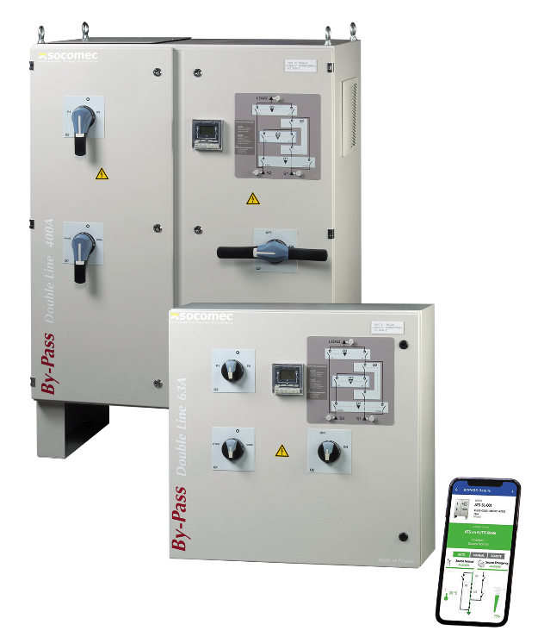

**Specification type**

Bypass SOLUTION

1. **General Characteristics**
   1. The enclosed Bypass solution must be composed by:

* A cabinet integrate all the equipment,
* An automatic transfer switching with a controller,
* A Bypass line to perform the bypass of the transfer switch
  1. The Bypass solution must be CE certified.
  2. All switching devices in the cabinet must come from the same manufacturer.
  3. The manufacturer of the solution must be ISO 9001 certified.

1. **Design**
   1. Bypass solution must integrate a compartmentalization of different devices.
   2. All functional units must be individually maneuverable, with separate handles, to ensure full redundancy.
   3. Bypass solution must allow manually transfer to Bypass mode without breaking of the load. The transfer can also be made off load.
   4. The Bypass position must integrate total isolation between the automatic transfer switch, source and load.
   5. In the case of double line bypass solution, it must be possible, in bypass mode, to select the source 1 or source 2 for supplying the load.
   6. The electrical characteristics must be identical in normal position and in bypass mode.
   7. Bypass solution must include a remote display on the front panel for easy access to configuration and measurements of the transfer switch.
   8. Bypass solution must be IP2X door open.
   9. Bypass solution must integrate terminal block for power connection in the lower part
   10. Bypass solution must integrate terminal block for auxiliary connection in the lower part.
2. **Standard compliance**
   1. Bypass solution must conform to IEC 61439-2.
   2. The solution should be tested in seismic resistance according to standards

* IBC2012
* UBC1997
* EN60068-3-3
  1. Integrated devices must comply with the following standards:
* CEI 60947-6-1 (transfer switching)
* CEI 60947-3 (load break switches)
  1. Controller of Transfer switch must be compliance of EMC standards

|  |  |  |
| --- | --- | --- |
| **Description** | **Std (IEC)** | **Requirement (criteria)** |
| Conducted | CISPR 11 | Class B |
| Radiated | CISPR 11 | Class B |
| ESD contact | 61000-4-2 | 4KV (B) |
| ESD air | 61000-4-2 | 8KV (B) |
| Electromagnetic field | 61000-4-3 | 10V/m (A) |
| RF Conducted | 61000-4-6 | 10V (A) |
| Burst | 61000-4-4 | 2KV (A) power 1KV (A) control |
| Surge differential | 61000-4-5 | 1KV (A) |

1. **Switchgear**
   1. Bypass solution must be proposed in versions 3 and 4 pole.
   2. The opening and closing of the poles and neutral must be synchronized by using the same mechanism.
   3. The system for opening and closing contacts must be independent of the control element. The speed of the contacts must be independent of the motor speed or maneuvering speed in the case of a manual changeover.
   4. The positions must not be affected by vibration or power supply variations. stable position without power.
   5. The automatic transfer switch must be equipped with a handle for maneuvering it manually in case of control failure or when power supply is absent.
   6. The automatic transfer switch must have a selector (or key) to select the automatic or manual mode. Furthermore, the manual mode should inhibit any automatic and electric remote operation.
   7. Bypass solution must integrate mechanical and electrical interlocking positions.
   8. It must be possible to padlock all the devices in position 0 (optionally in position 1 and 2). Padlocking of the automatic transfer switch will be possible only in manual mode (not inserted handle).
   9. Bypass solution must integrate a secure isolation.
2. **Integrated functions in the automatic transfer switch**
   1. The automatic transfer switch has a double power supply, which allows it to be powered by the source 1 and source 2.
   2. Features such as measurements, position monitoring and configuration parameters must be integrated into the automation.
   3. The controller must be communicating (RS485 Jbus / Modbus) to enable remote control, adjustment and access measures.
   4. The controller must allow the choice of the Network-Network Application or Network-Genset.
   5. The controller must integrate the start and stop functions of the genset and test on load and test off load. Group cooling time delay must be included and adjustable.
   6. The controler must include a control of three-phase voltages and frequencies of the two sources.
3. **Operation of the controller of the automatic transfer switch**
   1. Parameters and setting of the automatic controller
      1. The automatic controller must measure the voltage and frequency on all 3 phases supplying the power of the unit. This is to allow to detect the loss of one source and automatically activates the transfer. The thresholds and hysteresis voltage and frequency must be configured, as well as the phase unbalance thresholds.
      2. The automatic controller should realize a phase rotation control.
      3. The automatic controller should enable to select the type of network.
      4. The automatic controller should enable to select the source priority.
      5. The automatic controller should allow to activate the automatic re-transfer.
      6. The automatic controller will be equipped with a counter to view the number of changeovers have been performed.
      7. The set of configuration parameters of the product must be modified from the front keypad or through communication.
   2. For versions up to 160A the automatic transfer switch must be able to make a return to 0 without power.
   3. The automatic controller must be integrated in the complete set of automatic transfer switch.
   4. Changeover orders in the 3 positions should be achievable locally or remotely. During this operation, the automatic operation of the device must be inhibited, as well as manual operation.
   5. Controller interface
      1. The automatic controller must be easily configured from the interface with a password (4 digits).
      2. The interface will allow to easily visualize in real time the following parameters: voltage, currents, frequency, PF, power (apparent, positive & negative active and reactive energy)
      3. The physical position of the device (I, 0, II) should be indicated on the interface using LEDs.
   6. Timers setting, among other we must have:
      1. Loss of priority source to evaluate the failure of the main power source
      2. Emergency source presence, to ensure the stability of the backup source before failover
      3. Time of no supply of the load, adjusted in function of the voltage induced by the load.
      4. Back to priority source, to validate its stability before re transfer
      5. Cooling cycle in case of source type genset, before stopping in emergency source type genset.
      6. Shedding time, to allow the shedding of some part of the charge before transfer in emergency position.
4. **Utilization**
   1. On the door of the cabinet :
      1. A mimic diagram must be installed to a better understanding of the solution. It must include 3 LEDs: for availability source 1 and source 2 and for the supply of the load
      2. A remote interface must be present to access, voltage and frequency source, performed by the Automatic transfer switch.
   2. The remote interface must allow access to the configuration and monitoring of the automatic transfer switch.
   3. Different type of connection (BB/BT/TB/TT) will be possible under request.
   4. The use temperature of the Bypass solution must be between -20 ° C and + 70 ° C, accepting downgrades past 40 ° C.
   5. The solution must have 3 utilization modes: Normal, By-Pass and Test.
   6. Handles must be maneuverable without open the door of the cabinet.
   7. Communication means must allowed the ATS and other Bypass critical components to be remotely monitored and push alarms in case of critical event.
      1. From a SCADA or BMS
      2. From a mobile application, including real time monitoring of sources and ATS bypass
5. **Maintenance**
   1. The various disconnection devices integrated in the Bypass solution must not require any particular maintenance on the part of the user. The minimum maintenance required is to perform one operation every year. Technologies requiring contact replacement should not be accepted.
   2. To facilitate inspection of automatic transfer switch from 250A, they must be easy to extract.
   3. Automatic transfer switch must integrate test on load & test off load function.
   4. Maintenance and replacement of the controller & motorization of the automatic transfer switch can be made without disconnecting the power connection.
6. **Commissioning/Training**
   1. The manufacturer will be able to propose an offer of commissioning of the automatic transfer switch (configuration, testing on site) and a training offer for staff from the applicant.

The product must be similar to the solution ATyS Bypass.