**ELITE UPS: A MARK OF EFFICIENCY**

**Smart, secure, sustainable: Socomec signs up to JRC Code of Conduct for Elite level UPS efficiency that’s fit for the future.**

Benfeld, September 2022

*Global power management expert, Socomec, signs up to JRC Code of Conduct to define Elite level UPS efficiency.*

As a designer and manufacturer of UPS (Uninterruptible Power Supplies) equipment and integrated energy solutions, **energy efficiency** is always a priority for Socomec.

In an effort to go further in the protection of critical applications and processes – ensuring 24/7 continuous high quality supply – Socomec, as CEMEP\* UPS manufacturer member, has signed a Code of Conduct put forward by the Joint Research Centre of the European Commission (JRC\*\*). The JRC commits to mitigating energy losses and gas emissions caused by UPS equipment, therefore maximising UPS efficiency.

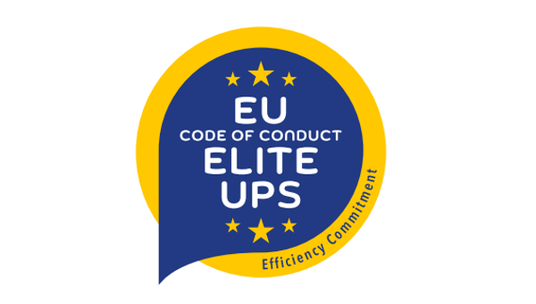

UPS equipment is a vital safety net that protects every electrical application from grid failure, providing immediate and continuous power until an alternative source or the grid can take over. Essential to every aspect of our lives – from telecoms to IT, healthcare, airports and data centres – without UPS equipment, the world as we know it today simply would not operate.

**A smart, secure and sustainable future**

Specific to UPS industry stakeholders operating in Europe, this UPS Code of Conduct sets out key energy efficiency requirements with criteria including quality and availability of the delivered power and operating modes.

The quest for greater energy efficiency has historically been a key driver of the UPS market, particularly given the importance of energy costs for users. In 2011 this was formalised by way of agreement between the main manufacturers and the JRC and was updated in 2022 with the launch of the Elite UPS trademark.

Luca Franzan, Marketing and Business Developer Director, Socomec explains; “Efficiency is at the heart of everything we do. We have made significant gains in this area over the last ten years, but we want to further formalise our commitment to making improvements in this field, by signing up to an Elite level set of requirements as part of this Code of Conduct, a requirement of the European Green Taxonomy. By adopting this voluntary Code of Conduct we are guaranteeing a safer and more efficient UPS for our customers – for a Smart, Secure and Sustainable future.”

NOTES

\***CEMEP UPS** is the Coordinating Committee for the Associations of Manufacturers of static Uninterruptible Power Supplies systems for industrial, commercial and similar use in the European Union. UPS manufacturers are driven by the same challenges: flexibility, hybridization of power sources, high availability and efficiency, sustainability of the products, connectivity, cybersecurity and standards compliance. They have been working for years with standardisation and European bodies like the Joint Research Center to improve and promote environmental aspects of UPS.

<https://cemep.eu/working-groups/uninterruptible-power-supplies-ups/>

\*\***Joint Research Centre (JRC) of the European Commission**

Over the last 10 years, the JRC of the European Commission has implemented projects under the name of Code of Conduct.

Subscribed on a voluntary basis, they provide users with best practices helping them in improving energy efficiency and reducing greenhouse-gas emissions.

Since 2008, members of CEMEP UPS are engaged in a voluntary agreement with JRC covering uninterruptible power systems. The latest 2021 update introduced the Elite Class UPS level in order to better drive the market towards the best performing products.

<https://ec.europa.eu/jrc/en>

|  |  |  |
| --- | --- | --- |
| **SOCOMEC: When energy matters** |  | **Press contact** |
| Founded in 1922, SOCOMEC is an independent industrial group with a workforce of 3600 experts spread over 28 subsidiaries in the world. Our core business: the availability, control and safety of low voltage electrical networks serving our customers’ power performance. In 2018, SOCOMEC posted a turnover of 537M€.  picto_785_a_en |  | **Luca Franzan**  Application Marketing and Business Development Director  + 39 0444598732  [luca.franzan@socomec.com](mailto:xxxxxxxx@socomec.com)  [www.socomec.co.uk](http://www.socomec.co.uk) |