Delphys Green Power 2.0 UPS: remains operational even after earthquake

Benfeld, 14th March 2014

Many critical infrastructures such as data centers, hospitals and emergency services have to remain operational under all circumstances, even after an earthquake. And needless to say, their continued electrical supply is absolutely vital.

The DELPHYS GP 160, 200 and 500 kVA/kW UPS from the Green Power 2.0 range have been tested by an independent certifying organization and have obtained seismic qualification for Zone 2A (site D), Zone 3 and Zone 4 levels of the American UBC-1997 building code as well as meeting requirements of European standard IEC 60068-3-3.

The tests
From the 1-4 October 2013, Socomec’s DELPHYS GP 160, 200 and 500 kVA/kW UPS from the Green Power 2.0 range underwent a series of stringent tests. These were carried out by VIRLAB, a testing body accredited by ENAC (the Spanish national accreditation organisation), involving a procedure drawn up in conformity with the USA Uniform Building Code (UBC 1997) and European standards IEC 60068-3-3 (seismic test methods), IEC 60068-2-6 (sine-vibration testing) and IEC 60068-2-47 (mounting of specimens for vibration, impact and similar dynamic tests).
The UPS were subjected to resonance tests along the three XYZ axes and to seismic tests along the “XZ” and “YZ” axes. The seismic tests that were carried out correspond to level Zone 2A (site D) of the UBC-1997 standard. They also comply with IEC 60068-3-3: 1993, that requires the carrying out of five S1-level tests (50% of the maximum level) before progressing to the S2 test (maximum level).
To complete the trials, a series of S2 tests corresponding to levels Zone 3 and Zone 4 of UBC-1997 were also performed.

The results
The DELPHYS GP UPS passed all the above mentioned tests with no detectable structural anomaly or deterioration.
The “0” qualification requirement defined in section 4.3 of standard IEC 60068-3-3: 1993 (that states “the equipment tested showed no malfunctioning during and after the test”) was met.

Key points of the range
Green Power 2.0 from 10 to 500 kVA/kW is the ideal solution for guaranteed service continuity of critical applications. DELPHYS GP 160-500 kVA/kW is the high power offering from Socomec’s Green Power 2.0 range that provides high availability as well as power supply protection up to 4 MW.
- Green Power 2.0 already complies with the energy efficiency requirements of the Code of Conduct 2014 concerning UPS systems.
- The Code of Conduct is a voluntary programme offering the PEP (Product Environmental Profiles) passport.
- Reduces energy consumption in factory testing procedures via the use of active loads (cutting CO₂ emissions by 90%).
- UPS with low carbon footprint.

Green Power: an award-winning range
In 2011, the Green Power UPS received the Frost & Sullivan Best Practice Award: “With its Green Power range of UPS, Socomec offers solutions with maximum efficiency and providing the highest levels of protection. The manufacturer is committed to increasing advantages for its customers by supplying high performance products for a low total cost of ownership”.
Frost & Sullivan also welcomes Socomec’s long-term commitment to create innovative products designed for critical electrical applications. The Green Power UPS meet the most stringent requirements for the protection of the environment without compromising output, even for the most demanding applications.

Photo
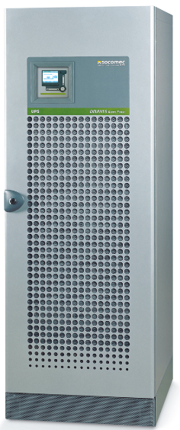
For a HD version of this photo: click here
ABOUT SOCOMEC |  | FOR MORE INFORMATION
Founded in 1922, SOCOMEC is an industrial group with a workforce of over 3000 people around the world in 21 subsidiaries. Our core business: the availability, control and safety of low voltage electrical networks… with increased focus on our customers' power performance. In 2014, SOCOMEC posted turnover of 427 million euros.  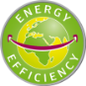 |  | Press contact: Virginie GUYOT  Offer Communication Manager  Tel. : +33 (0)3 88 57 78 15  E-Mail: virginie.guyot@socomec.com  www.socomec.com

