Product Upgrade Tool – User Manual
Date : | From : LE GAL Grégory | Verified by :
To :
Copy to :

Contents
Software Installation: 2
How to use ‘Product Upgrade Tool’ : 5
Log File : 8
Software Recommendation: 8

This document explain how to upgrade all equipment from DIRIS DIGIWARE new measurement.

Software Installation:
Before to begin the installation, ensure you that all the previous installation af flasher are uninstalled from the system.

Execute ‘ProductUpgradeTool_v1_3_0_0(32bits_64bitsEdition).exe’ file

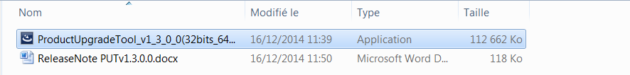

An installation popup appear. Click next, accept License agreement on the next popup and click next again.
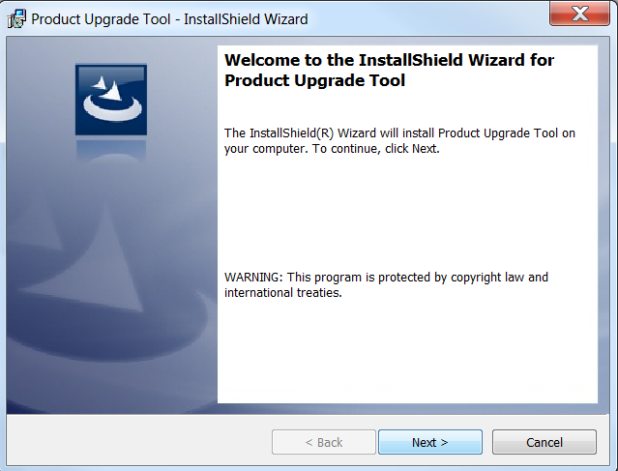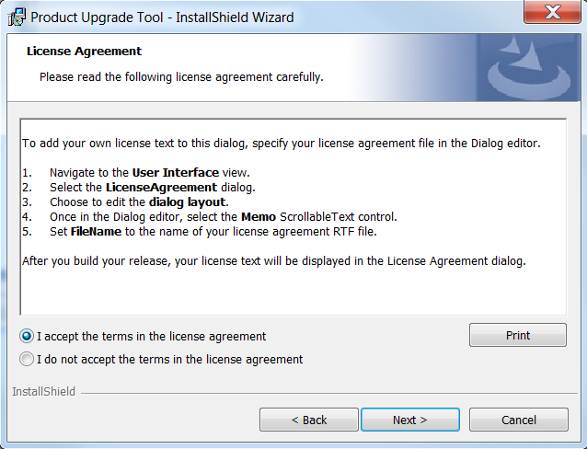
Enter your name and company name, click next and finally click on install button.
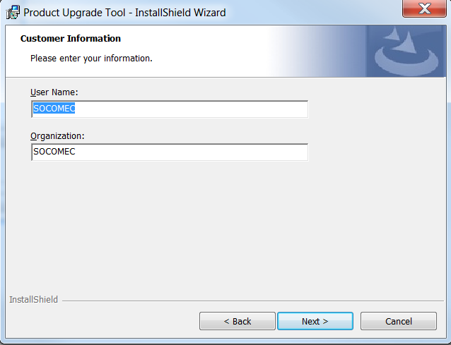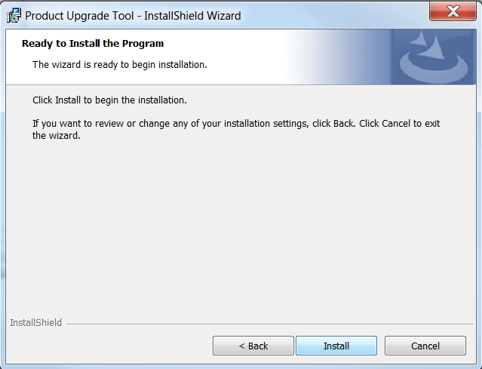

During the installation, the program ask you to install to another program named respectively DfuSe from STMicroelectronics and Virtual COM Port Driver which are mandatory for the Product Upgrade Tool
A new popup appear for DfuSe v3.0.3 installation. Click next and accept the license agreement from the next windows.

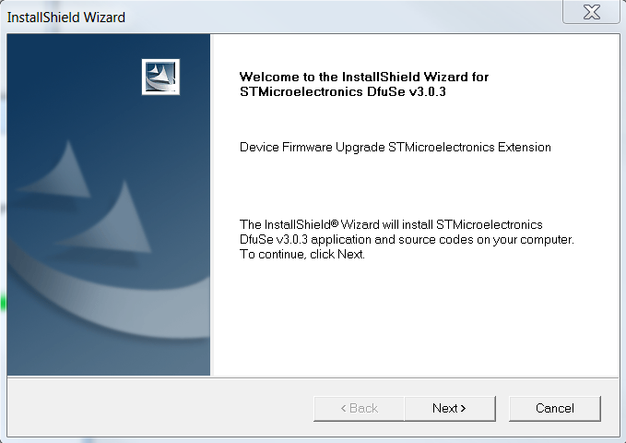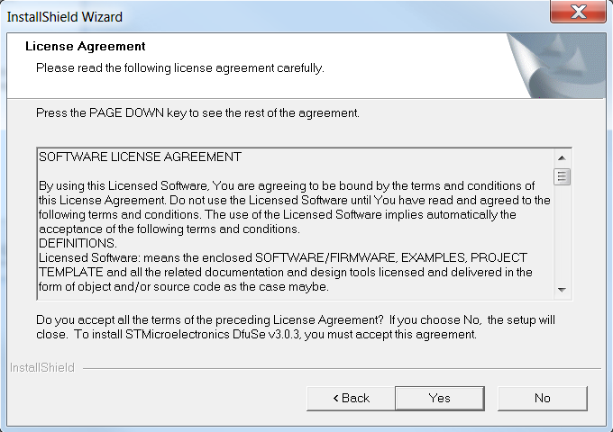

Enter your name and your company name and Choose the directory where you want to install the software

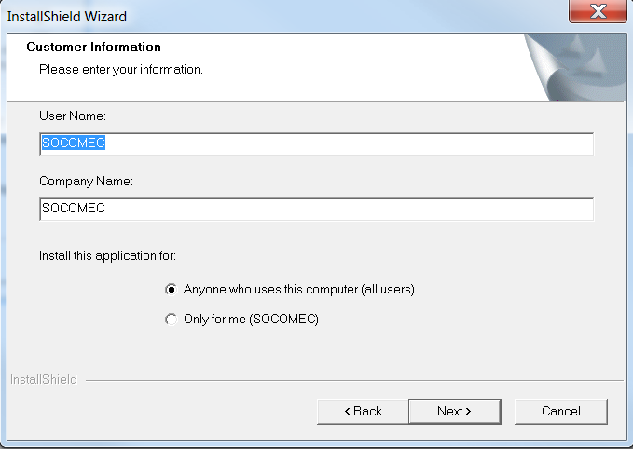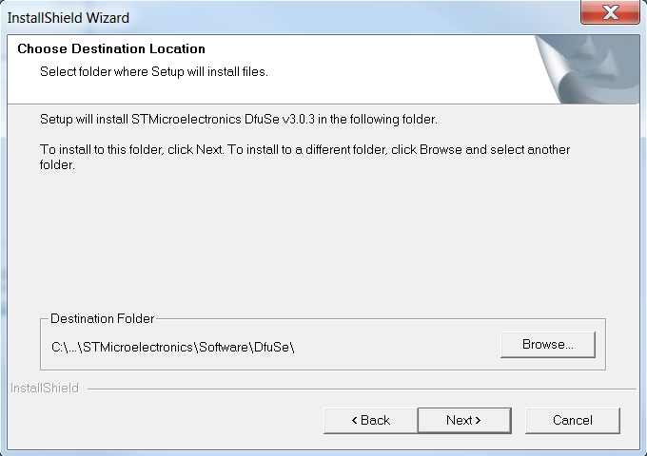

After the complete installation of DfuSe, a new popup appear to install the driver for PUT for COM communication from USB port. Click next to install it.
After the installation a new popup appear to install the drivers. Click next to continue.

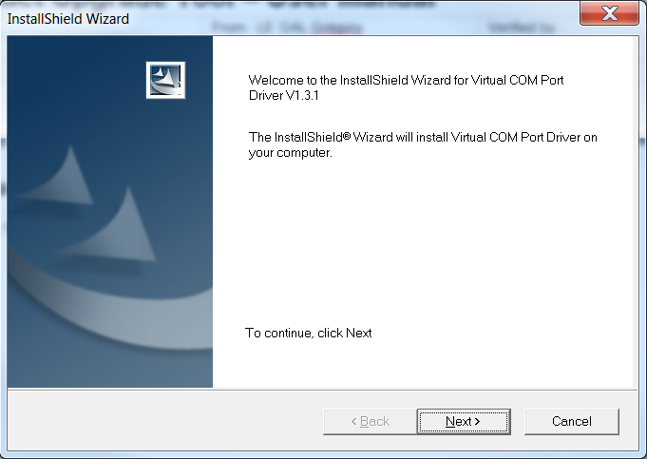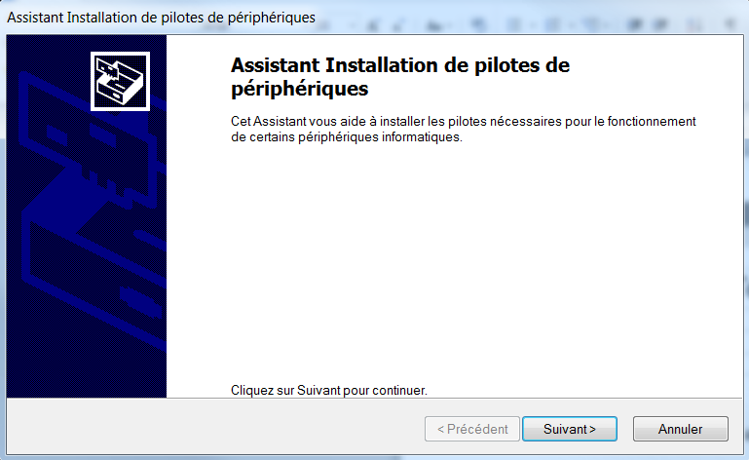

Click on finish to complete the driver installation and click on finish to complete the Product Upgrade Tool installation.

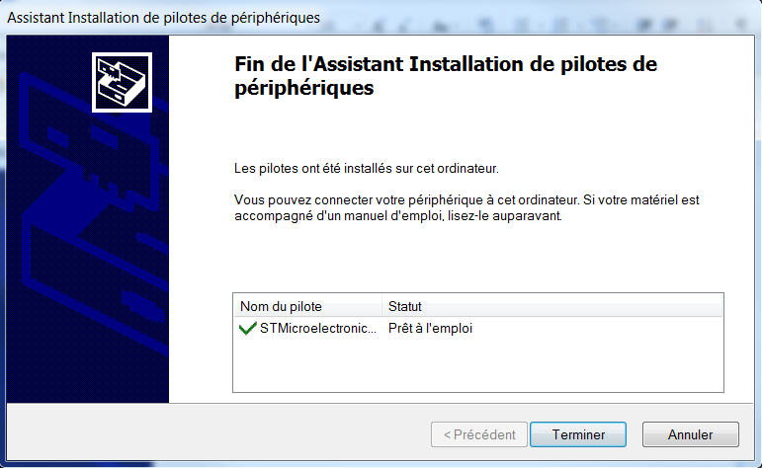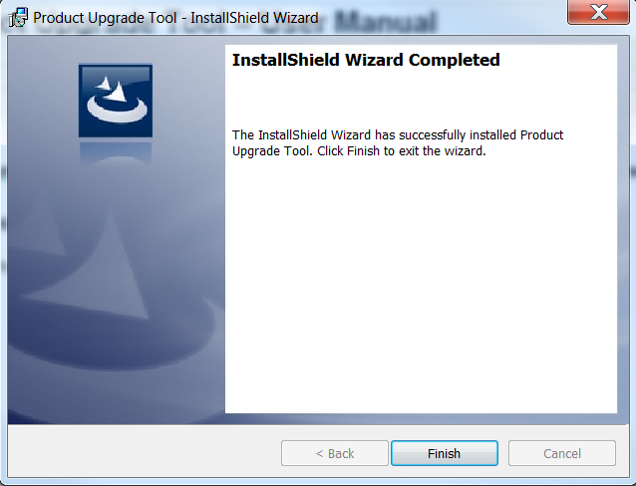

A new entry is available from the start menu :
Select ‘Product Upgrade Tool’ to start the program.

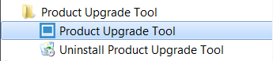

How to use ‘Product Upgrade Tool’ :
First of all, plugged your equipment to an USB port of your computer. Next start the program from the start menu.
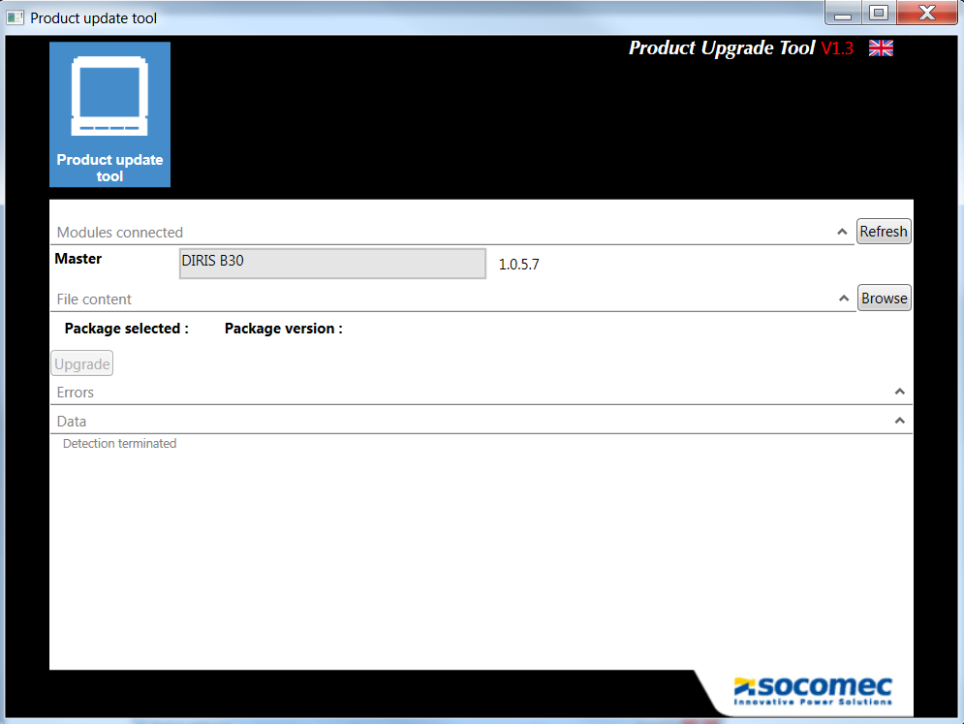
Language selection
Version number
Modules connected
Package information
Errors displayed
Informations displayed

When the equipment have been detected, you can load a package to update the product.
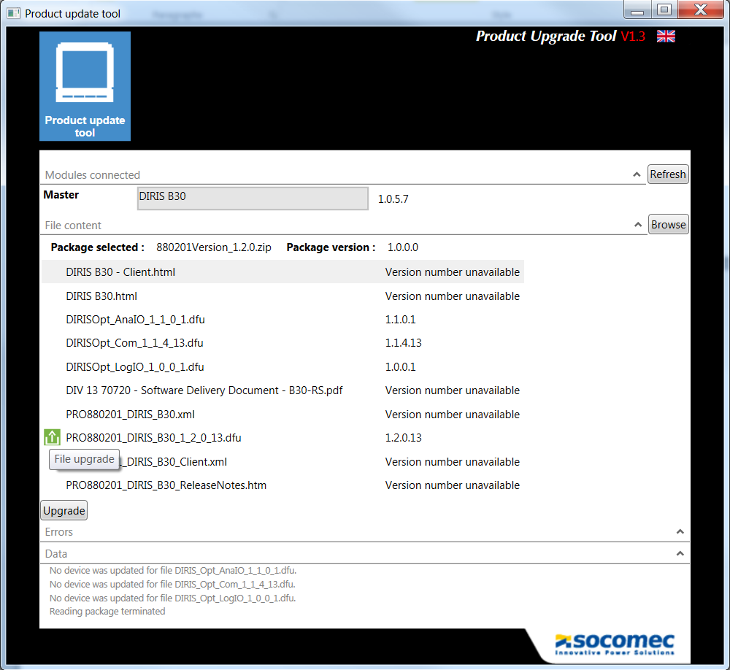
When the package is loaded, it displays all is information and each version number found for files.

PUT displays the action done if the user clicks on update button. It contains three symbol to help the user to distinguish which action will be done on each module.


Downgrade Stationary Update

The last step is to launch the update. Click on ‘Upgrade’ button.

A first question is asked to the user. The package contains the information to ask the user to Reset factory Settings in mode ‘Forced’ or ‘Manual’. The difference is that the first option force the user to validate if he wants to continue the upgrade. The same kind of question is ask for the reset of histories.

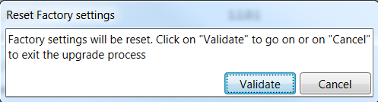

If the user decline to validate then he is forced by the system, the process is stopped and the upgrade doesn’t continue. A message is displayed to the user.
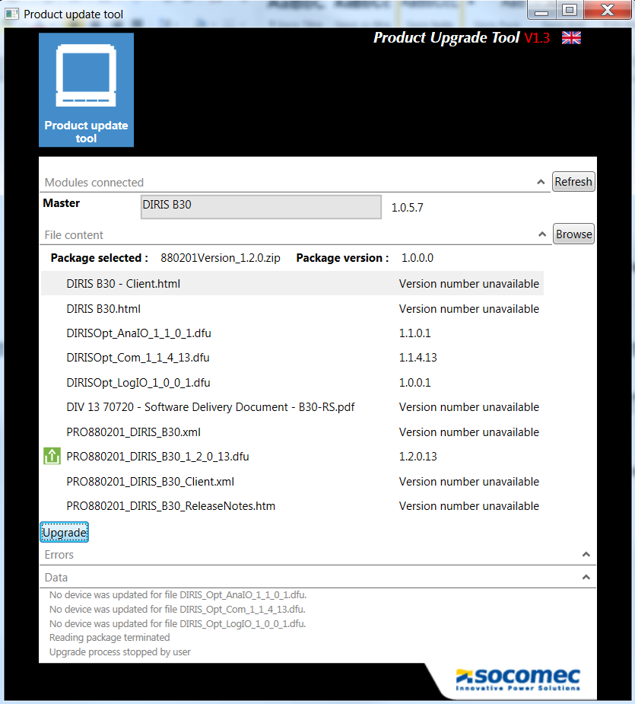

In the other case, the PUT start the upgrade of firmware
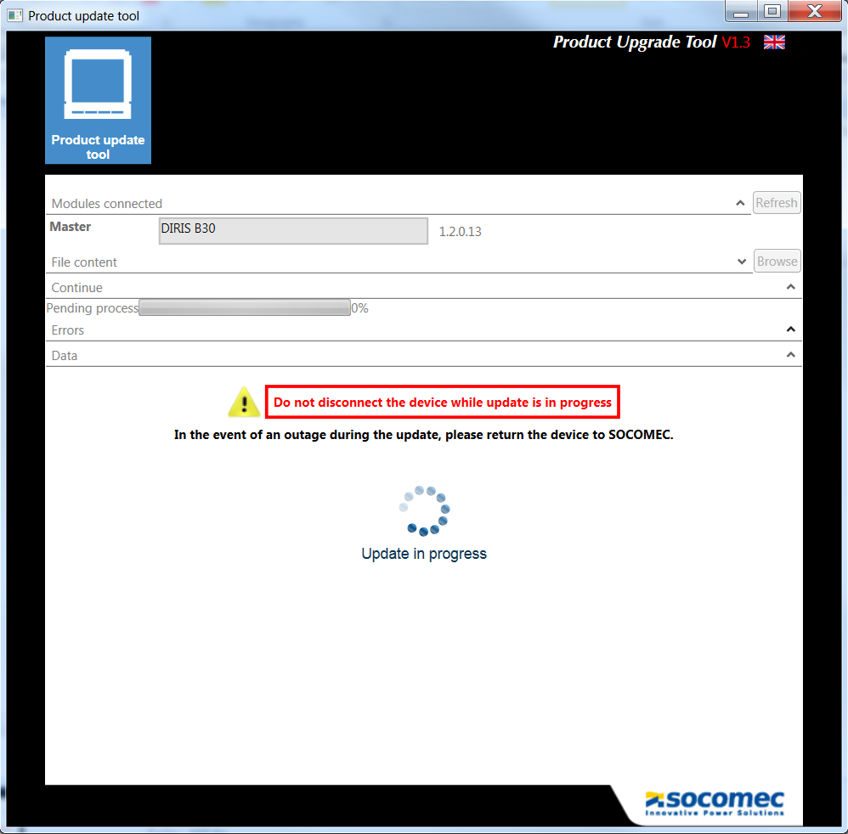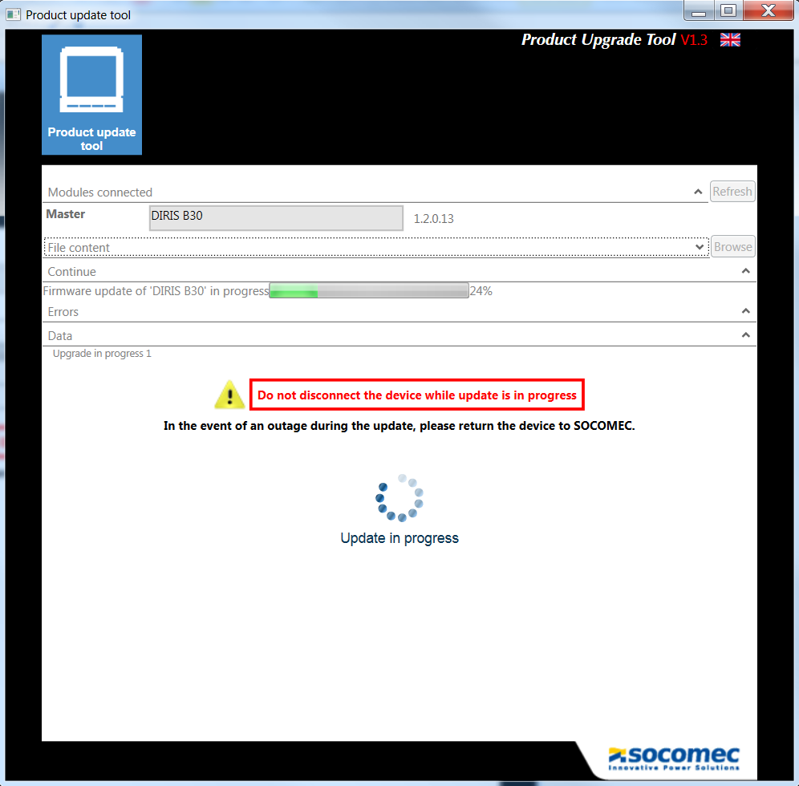

To finish, a green message is displayed if the upgrade is done without error, otherwise a red message is displayed.
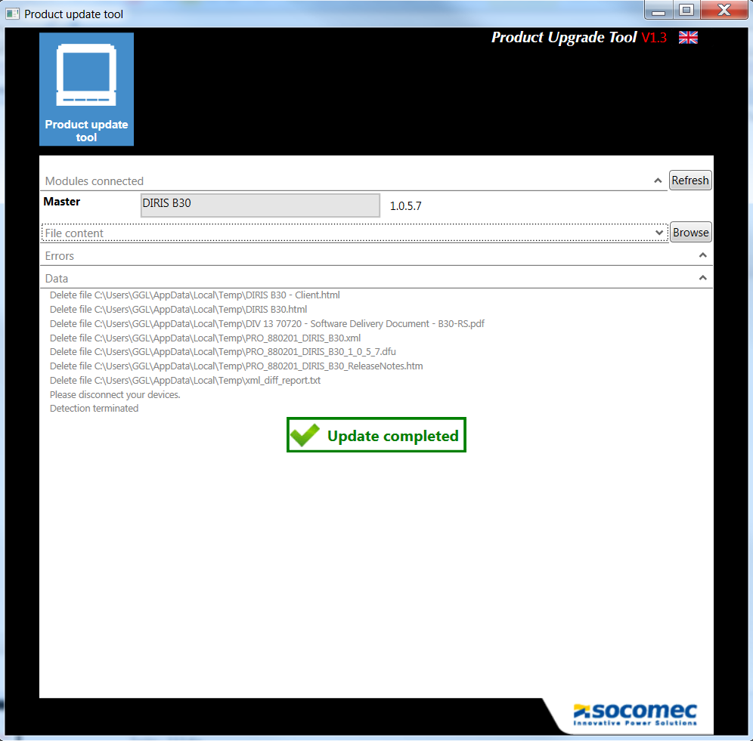

If there is one or more errors during the update process, PUT retry to update the firmware three times before display an error for upgrade.
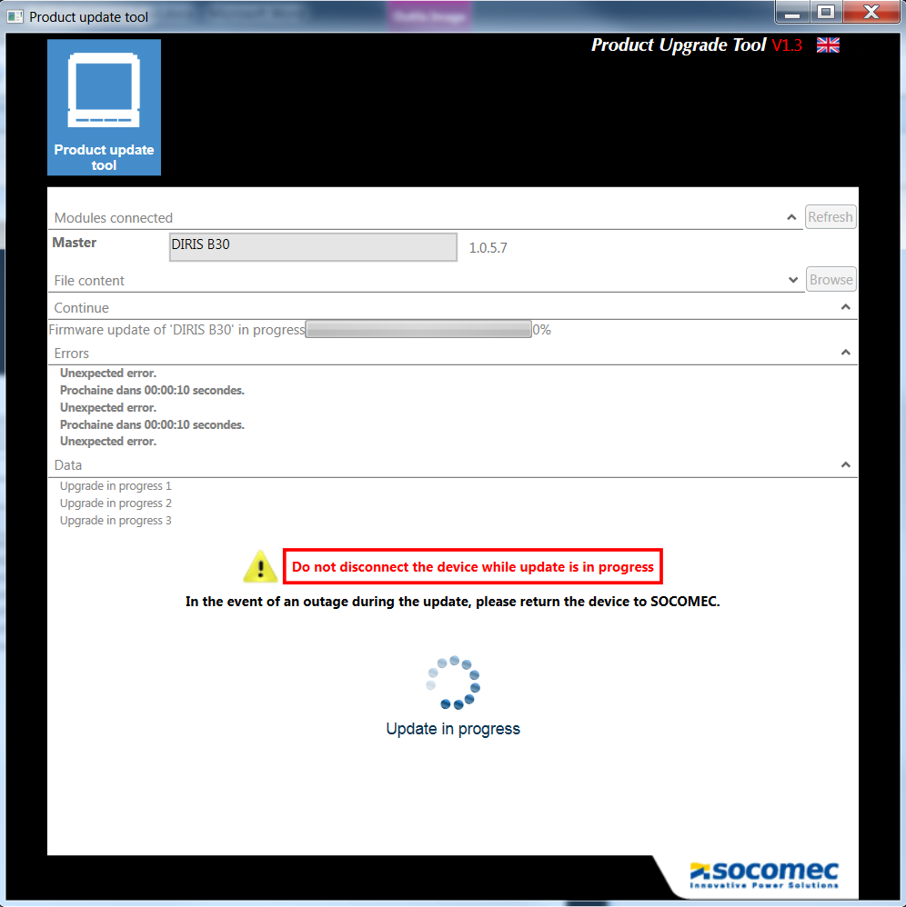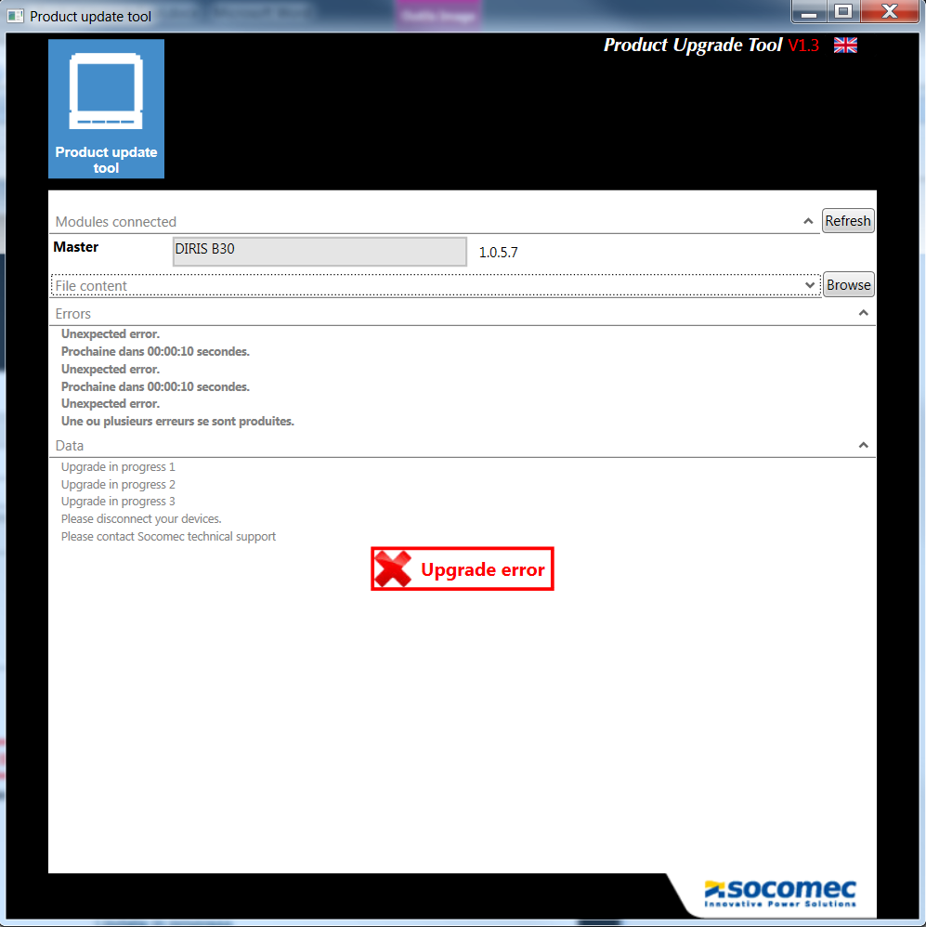

Log File :
All the process and errors are log into a file on the disk. A file that the user can access with his account.

Filename: logFlasher.txt
Path: Depending of TMP or TEMP variable defined on the computer.
To find it click on ‘My computer’ and on ‘advanced system parameters’ Open the ‘environment variable’ and check TEMP or TMP variable.
The value ‘%USERPROFILE% is a window variable corresponding to :
C:\Users\<username connected to the computer>

In the major case, the temp variable corresponding to this path:
C:\Users\<userame>\AppData\Local\Temp

The log file capacity is 2Mo. When the log file reaches this length, it is saved under a new name containing date and time. It has the following format:
DDMMYYY_HHMM_logFlasher.txt

Software Recommendation:
- Use only the package provide by SOCOMEC

